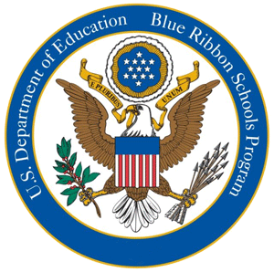

**National Blue Ribbon Schools of Excellence**

[*CLICK HERE*](http://www2.ed.gov/programs/nclbbrs/index.html) *for more information!*

Otwell MS 1990-1991

Big Creek ES 2000-2001 & 2011

Daves Creek ES 2013

South Forsyth MS 2014

Johns Creek ES 2015

Sharon ES 2016

Big Creek ES 2017

Brookwood ES 2017

Riverwatch MS 2017

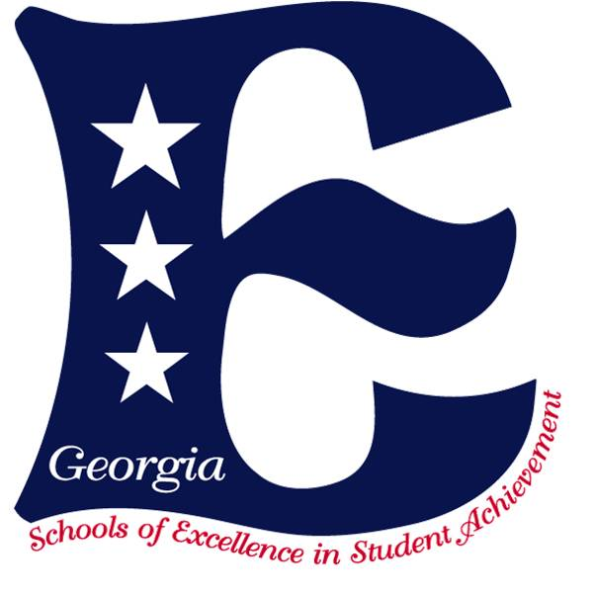

**Georgia Schools of Excellence**

[*CLICK HERE*](http://www.doe.k12.ga.us/External-Affairs-and-Policy/Excellence-Recognition/Pages/Schools-of-Excellence.aspx) *for more information!*

Big Creek ES                          2000, 2007 & 2012

Chattahoochee ES                2001 & 2006

Daves Creek ES                       2009

Mashburn ES                           2005

Matt ES                                     2007

Midway ES                               2006

Sharon ES                               2008

Settles Bridge ES                    2006 & 2011

Shiloh Point ES                        2011

Vickery Creek ES        2011

North Forsyth MS   2000 & 2007

Otwell MS                                  2008

Riverwatch MS                        2009

South Forsyth MS  2010

Forsyth Central HS               2001

North Forsyth HS             2000

South Forsyth HS             2008